Alejandro Lopez
A2: Individual Assignment
Hult International Business School
Word Count: 1840


Introduction
As Smooth Ride ventures into the UK electric vehicle industry, it is essential to model consumers' willingness to pay for vehicles and their attributes. For the company, entering this market with Basic and Premium EVs requires more than product development; it requires a structured understanding of what consumers value and how operational constraints shape profitability. This report focuses on the company's use of a conjoint design to model customers' preferences across electric vehicle attributes, allowing them to see which features drive purchase decisions and to what degree. A linear programming model is then applied to identify the profit-maximising production mix between Basic and Premium units under varying resource and capacity constraints. These tools combined give Smooth Ride a strong foundation for product positioning and operational planning.

Proposed conjoint design
To accurately model customers' willingness to pay for an electric vehicle based on its attributes, a conjoint study is proposed with five attributes: Battery Range, Charging Speed, Vehicle Size, Acceleration, and Price. (Table 1)
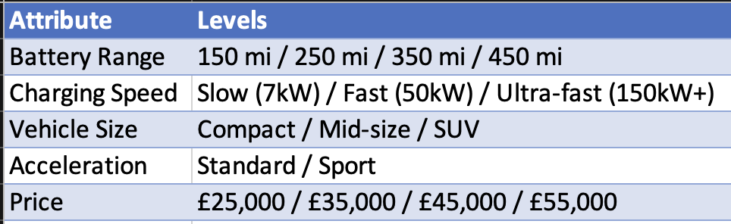
Table 1: Proposed Design
Battery range addresses range anxiety, one of the biggest concerns for customers considering an electric vehicle. The four levels cover most customer needs, from entry-level urban vehicles to long-range premium models. Charging speed is included as a separate attribute because it addresses how quickly a vehicle can replenish the energy it has consumed. This is particularly relevant in the UK market, where the distribution of fast-charging outlets is sparse outside of major cities. Vehicle size aligns with urban and suburban preferences, and the binary classification of acceleration serves as the key differentiator between the Basic and Premium vehicles.
This design reveals 288 different vehicle profiles, which would not be feasible to present to participants individually. A reduced set of approximately 36 carefully selected profiles should be used instead, ensuring no two attributes are correlated across the survey so that each attribute's effect can be estimated independently.

Pros and Cons of a Conjoint design
Conjoint analysis can add significant value to Smooth Ride's market research objective. Unlike preference surveys, conjoint analysis captures real consumer trade-offs by having respondents evaluate complete product profiles, producing numerical utility scores that allow the company to efficiently analyse patterns across multiple customers. Utilising profiles in the design effectively simulates customers' real-life purchasing decisions. This is especially effective in pricing strategies since it reveals how much utility customers are willing to trade off for a lower price. Directly informing Smooth Ride's Basic and Premium positioning.
However, there are some significant limitations to utilising this conjoint design. One specific issue with this design is the binary levels of the size and pickup profiles; the binary classification prevents the model from detecting nuance in consumer preferences, as some respondents may prefer an option that falls between the two extremes presented. Additionally, the design might struggle with multicollinearity, since a feature like price might be directly correlated with an attribute like battery size; the regression cannot cleanly separate the effects of each attribute. This inflates standard errors and makes coefficients unreliable. Another limitation of a conjoint design is that it assumes utility is purely additive, meaning total preference is the sum of individual part-worths, yet in reality, attributes interact in ways the model cannot capture. Finally, the model represents a static snapshot of consumer preferences, which is a significant limitation in the rapidly evolving UK EV market
Analysing customer preference

Using data collected by Smooth Ride, a regression analysis was run on 36 profiles using the preference score as the dependent variable. Dummy coding was applied to the attribute levels, removing one reference level per attribute to avoid the dummy variable trap. The model achieved an R² of 0.80, indicating that 80% of preference variation is explained by the four attributes, a strong fit for a conjoint model of this scale. The estimated part-worth utilities for each level are presented in Table 2.

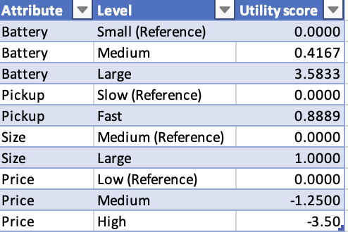

Table 2
The part-worth utilities allow us to compare which of Smooth Ride's two proposed vehicles customers would prefer, as shown in Table 3. Product A achieves a total utility of 6.44 compared to 4.47 for Product B, making it the clearly preferred option. This is notable because Product A carries a high price penalty of −3.50, which has been shown to be one of the attributes with the greatest impact on customer preference. However, the large battery utility of +3.58 more than compensates for this, demonstrating that customers are willing to pay a premium price if the vehicle offers sufficient range.

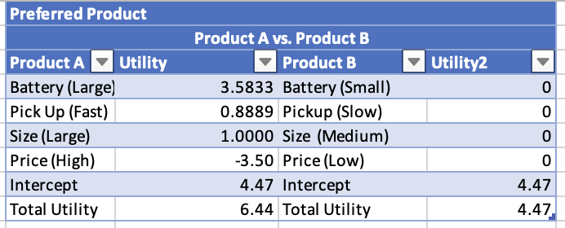
Table 3: Utility score Product A & Product B

To calculate the most important attribute, the attribute’s range is divided by the range of all attributes. This revealed that the battery was the most important attribute. at 39.9%, followed by Price at 39.0%. The rest of the attributes, like pickup and size, proved considerably less important, indicating that customers are making genuine trade-offs between specifications and cost, which validates Smooth Ride's two-tier Basic and Premium strategy.

Pros and cons of this approach

This method is a straightforward way to estimate attribute importance, as the utility ranges can be calculated directly from the regression coefficients without collecting any extra data. Additionally, regression provides statistical significance for these attributes, allowing differentiation between genuinely significant attributes and noise. Lastly, this approach’s simplicity allows board members and managers who might not have technical expertise to easily understand it; however, it also carries significant limitations. First, significance levels are sensitive to attribute levels, meaning a narrower battery range would have produced lower battery importance. This method is also purely additive, meaning it can't detect interaction effects between attributes, such as when a large battery and fast charging are worth more together than separately. One last significant limitation is that the 1-10 rating doesn't mirror the real-life customer experience of making trade-offs, since the participants can rate all high-spec profiles highly regardless of whether they could actually afford them.

Optimisation: 20 Resources

Smooth Ride seeks to maximise its profits, π = 1·B + (1+α)·P, where B and P represent the number of basic and premium cars produced, respectively. This is subject to three constraints: a combined production capacity of 10 cars and a resource limit of 20 units, where each basic car requires 2 resources and each premium car requires 4. The variable ‘a’ varies with supply chain conditions, commodity prices, or a competitor’s discount. Table 4 presents the optimal production mix across α values from 0 to 3.

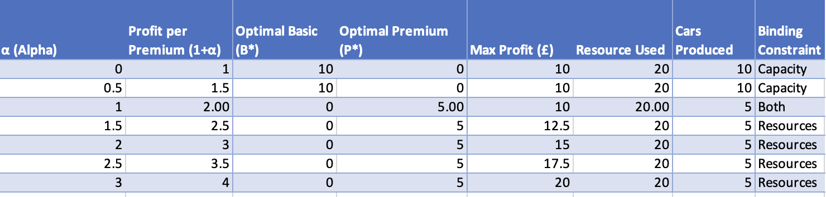

Table 4: Sensitivity analysis 20 resource units

The model reveals a tipping point at a = 1. When α is below 1, the profit per premium car is insufficient to justify its higher resource consumption. This means that in cases where 'a' is less than 1, the optimal solution would be to maximise the resource and capacity constraints in producing basic model cars for a total profit of £10. At points where 'a' is equal to 1, both products generate equal profits per resource, and the model is indifferent, with both constraints binding simultaneously. Once α exceeds 1, Premium becomes strictly more profitable per resource consumed, and the optimal solution shifts entirely to 5 premium cars with the resource constraint becoming the limit. Profit then scales with α, reaching £20 at α = 3.

Optimisation: 25 Resources

In the scenario where Smooth Ride has 25 resource units, the maximisation model changes, as seen in Table 5. First, even at the lowest value of α = 0, the extra resources make it optimal to produce a mix of 8 Basic and 2 Premium cars rather than 10 Basic cars, as the capacity constraint binds before resources are exhausted. In this case the tipping point also comes when alpha reaches 1; however, in this case the basic cars become less profitable to produce, and producing only 6 premium cars becomes the optimal strategy. This increases maximum profit from £20 to £24 at α = 3. The additional resources, therefore, do not change the fundamental logic of the tipping point. This implies that investing in additional supply chain capacity would be most valuable when market conditions favour the premium model.

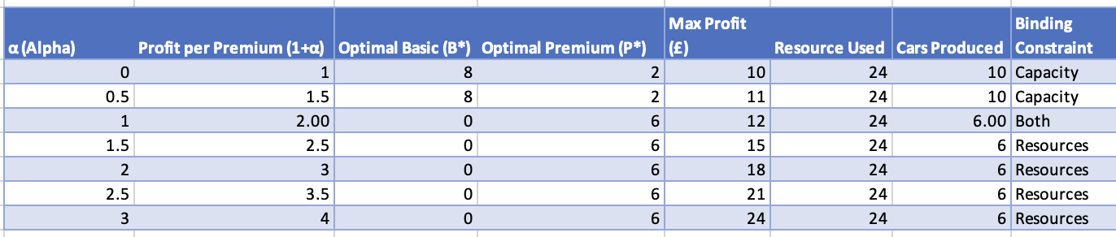
Table 5: Sensitivity analysis 25 resource units

Optimisation: Capacity of 8

In the case where Smooth Ride has a reduced production capacity of 8 cars instead of 10, their situation changes. As shown in Table 6, this change has its most significant impact at low values of α. When α is below 1, and the capacity constraint is active, the maximum number of basic cars falls from 10 to 6, reducing maximum profit from £10 to £8 at α = 0. The optimal strategy adjusts to 6 basic and 2 premium cars to fill the 8-car capacity while staying within the 20-resource budget. In this case, the tipping point stays at a = 1, where production moves entirely to 5 premium cars, since the resource budget is exhausted beyond this point. This shows that capacity disruptions are most punishing for profits when Smooth Ride is focused on high-volume production of basic cars, but have little to no effect on profits once premium production becomes optimal. Smooth Ride should therefore treat capacity risk as most critical during periods where market conditions keep α below 1.

Practical Advice for the CEO

Linear programming provides a powerful and transparent framework for understanding how resource and capacity constraints interact with profitability. This method's main strength for the company is its ability to perform a sensitivity analysis, allowing them to identify optimal production strategy changes without the expense of trial and error. This model is very easy to explain to non-technical stakeholders, and, lastly, its outputs can be updated quickly as market conditions evolve.
This method also has some limitations. The model is static, optimising for a single period under fixed constraints, whereas real production planning involves demand uncertainty, lead times, and inventory decisions across multiple periods. Resource consumption per unit is assumed to be fixed, whereas in reality, the resources required per premium car may vary with production volume or supplier terms. One of the major limitations of this model is that it focuses solely on production, does not account for demand, and assumes Smooth Ride can sell whatever it produces, which may not hold in a competitive market.
The main recommendation to the CEO of Smooth Ride is to use these models as a compass rather than absolute rules. The tipping point at α = 1 is an actionable insight that should be actively monitored. When premium profitability crosses this threshold, resources should be reallocated promptly. Additionally, these models should be complemented with demand forecasting and scenario planning to mitigate uncertainty around variables such as supply chain and competitor discounts, ensuring that Smooth Ride's production decisions remain responsive to real market conditions. Furthermore, the conjoint analysis reveals that battery and price are nearly equal in importance for the customers at 39.9% and 39.0%, suggesting a segment of consumers who value range but remain price-sensitive. Introducing a mid-tier model between Basic and Premium could capture this undecided segment. And the linear model could be expanded to implement this new design.

